Impact of ICT Investments in Southern African Countries
Final Project Report – Spring 2012
Submitted by:
BIA 650 – Process analytics and optimization
Prof. Edward A. Stohr

Table of Contents

Abstract: 3
Introduction: 3
Overview of ICT Infrastructure in Africa: 4
Background on the Countries: 5
Research Method: 8
Data Collection: 11
Discussion of Results: 12
Conclusion: 16
References: 16
Appendix A 19

Abstract:

Africa has been suffering from poverty and colonization. This made the development of the countries to move at snail pace. But the growth of Information Communication Technologies (ICT) has carved out an alternative path for development. There has been a very rapid growth of the ICT markets over the last decades. The ICT has played an important role in African countries and has shown tremendous success. Many African countries are now investing heavily for the national information infrastructure, so that they can participate in the economic and social development. All the countries in Africa have been investing in ICT constantly. Therefore, there is a necessity for us to research about the investments made in ICT and its impact. In this research paper, I will show that fifteen of the Southern African countries are technically efficient with regard to the ICT investments and also the ICT investments made are generating a revenue growth. This analysis uses Data Envelopment Analysis (DEA) methodology to query the impacts of ICT investment on the fifteen Southern African countries for the year 2000 and 2009. The use of DEA approach for the analysis of the productivity is not new. It has often been used to measure the relative efficiency of ICT sectors in developed and developing countries for the development of the economy.

Introduction:

Almost all the nations in Africa have been investing heavily in ICT as an answer for the development and economic growth of the countries. ICT plays a very important role in increasing the efficiency of the economy. It provides access to new services and markets, creates new opportunities for income generation and improves governance. Africa has a wide diversity and different approaches are required for establishing ICT. Occasionally investing in ICT does not allow a rapid increase in growth rates. As a main part of the development approach, ICT has to be given importance in the sectors that would be productive and also promote economy. Many Scholars have been arguing that ICT can contribute to economic growth, when it is used in the correct way for the right purposes.

As there are many benefits from ICT, there are also hardships for utilizing ICT. The main hindrance for utilizing ICT for economic development in African countries is due to the fact of absence or limited availability of the existing basic ICT infrastructure, especially in the rural areas. The essential ICT infrastructure is robust in few countries and in the urban areas. And majority of Africa’s population live in the rural areas, where the people are beyond the reach of ICT. ICT is most of the time constrained in few areas where the ICT infrastructure is present, there exists a deficiency of supporting infrastructure like electricity and transport systems.

The theme of this research paper is to perform a DEA analysis on the factors contributing to the impact of ICT investment with regard to its utilization in the Southern African countries namely Angola, Botswana, Democratic Republic of Congo, Kenya, Lesotho, Madagascar, Malawi, Mozambique, Namibia, South Africa, Swaziland, Tanzania, Uganda, Zambia, and Zimbabwe. The analysis was concentrated to two main questions (1) Are the ICT investments resulting in Revenue growth? (2) Are the Southern African countries technically efficient with regard to the ICT investments and utilizing ICT? To analyze the relative efficiency of these countries, Data Envelopment Analysis (DEA), is used, a well known and widely used method for evaluating the economic units such as countries, local governments, and industries (Shafer and Byrd, 2000; Wang et al., 1997; Chen and Zhu 2004; Färe and Grosskopf, 2005).

Overview of ICT Infrastructure in Africa:

From the end of 1990s, the telecommunication services have been increasing rapidly across the Southern African countries. Mobile networks have been expanded and the cost has fallen which has brought the basic ICT services to the reach of majority of the Africans. ICT has become a household service which is available to many more Africans. ICT plays an important role for the social and economic development of a country. Several African nations together formed the African Information Society Initiative (AISI), a framework for building ICT infrastructures in Africa (Okello, 2010). The AISI provides support for the development of ICT infrastructure.
Even though Africa’s ICT infrastructure has grown as the sector was expanded, it still faces challenges in the sector when compared with rest of the world. The network architecture is very different in Africa. They still make use of the traditional ways of integrating the networks. The mobile networks are mainly wireless everywhere and fiber optic cables and fixed wireless technologies are not being used. Presently, the fiber optic networks in Africa are developing quickly. Most of the countries have been encouraged to invest in the fiber optic networks which will make possible to connect many more countries and giving rise to new services and better ICT facilities. Broadband generates more volumes of traffic. Major part of this traffic is international because the content that is accessed over the Internet is stored in countries and not where the user is located. Majority of the international bandwidth traffic in Africa is routed through Europe to its incumbent destinations. (ITU, 2007b; UNCTAD, 2010). This is very true in the case of Africa because it hosts very little Internet content when compared with rest of the world. Therefore, the international networks have been an important constraint on the development of cheap broadband services. Recently in 2010, 12 submarine cables were operational in the Southern African region. These submarines have a huge capacity of 12 terabits per second (Tbps). An additional five submarines will be invested which costs about $1.7 billion and this will bring about 9 Tbps of capacity to the region. Now we can see the international bandwidth available to Africa is growing. This was one of the major problems in Africa and will no longer be a hurdle on the ICT sector in the near future.

Background on the Countries:

Africa has totally 56 countries, where six are in North Africa and the remaining 50 countries are in the Sub-Saharan region. The African continent has been grouped into regions based on the geographic and economic structure. In this study, I have collected data for 15 countries that are all located in the Sub-Saharan region. These countries are grouped on the Human Development as Medium Human Development under which the countries are Botswana, Namibia, South Africa, Swaziland, Kenya, Madagascar, Lesotho, Uganda, and Angola. Under Low Human Development countries are Tanzania, Zambia,
Malawi, Mozambique, Democratic Republic of Congo, and Zimbabwe.
Basically the African countries are grouped into four regions based on geographic and economic standards: Southern African Development Community (SADC), Economic Community of West African States (ECOWAS), Eastern Africa (EA) and Northern Africa (NA).

The SADC consists of 15 countries in its region. The main aim of SADC is to extend full support to the human development. The vision of the community is to bring back the culture, principles, positive values, and history which were present among the people of the region before colonization. The SADC originated in the 1960s and 1970s when the colonization was coming to an end. It was formally established by the Lusaka declaration in the 1980. Each member of the region is committed to the development of ICT, human resources and economic integration. The combined population of the countries in SADC is over 200 million and 80% of the people are still living in the rural regions. During the 1990s the countries experienced growth in the ICT sector. Angola, Botswana, Democratic Republic of Congo, Lesotho, Malawi, Mozambique, Namibia, South Africa, Swaziland, Tanzania, Zambia, and Zimbabwe are the SADC countries selected for this study.

Botswana, Namibia, South Africa, Swaziland, Lesotho, and Angola are ranked as the medium in terms of the human development. These countries have populations varying from 1.2 million (Swaziland) to 50.7 million (South Africa), with an average of 42% people living in the urban areas and 81.06% average literacy rate. Democratic Republic of Congo, Malawi, Mozambique, Tanzania, Zambia, and Zimbabwe are ranked as low in terms of human development. These countries have populations varying from 13 million (Zimbabwe) to 69.5 million (Democratic Republic of Congo), with an average 27% of people living in the urban areas and 69.68% average literacy rate.

The SADC countries have been increasing their investments in ICT and its usage ever since 1994. Table 1 below shows some of the demographic data for these countries.

Eastern Africa (EA) consists of about 19 countries which are bounded by geography. In this particular study Kenya, Uganda and Madagascar are under this region. Earlier Madagascar was also part of the SADC countries, but its membership was recently suspended. Kenya and Uganda are part of the Common Market for Eastern and Southern Africa (COMESA). Its key goal is the development the economy and ICT investments for infrastructure. These two countries are also part of the East Africa Community (EAC), this a regional group which helps in promoting the infrastructure and financial institutions in its member states. The populations of these three countries are 42.7 million (Kenya), 35.6 million (Uganda), and 21.9 million (Madagascar). The average literacy rates of the three countries are 73.6%.

Countries | Population (millions) | Literacy Rate % | Life expectancy
Angola | 13.3 | 67.4 | 38.76
Botswana | 2 | 81.2 | 58.05
Democratic Republic of Congo | 71.7 | 67.2 | 55.33
Kenya | 41 | 85.1 | 59.48
Lesotho | 1.9 | 84.8 | 51.63
Madagascar | 21.9 | 68.9 | 63.63
Malawi | 15.8 | 62.7 | 51.7
Mozambique | 22.9 | 47.8 | 51.78
Namibia | 2.1 | 85 | 52.19
South Africa | 49 | 86.4 | 49.33
Swaziland | 1.3 | 81.6 | 48.66
Tanzania | 42.7 | 69.4 | 52.85
Uganda | 34.6 | 66.8 | 53.24
Zambia | 13.8 | 80.6 | 52.36
Zimbabwe | 12 | 90.7 | 49.6

Table 1: Demographic Background data for the countries

_{*Source: http://www.aneki.com/}

Research Method:

The method employed for this study is the data envelopment analysis (DEA), which is used in operations research for calculation of production frontiers. It is used empirically to evaluate the performance of decision making units (or DMUs). DEA was developed by Farrell (1957) who drew upon the work of Debreu (1951) and Koopmans (1951). The DEA development has seen many significant contributors, including Charnes et al. (1978, 1979, 1981, 1985, 1989), and Banker et al. (1984).

Currently DEA is receiving increasing importance as a tool for evaluating the performance of decision making unit (DMU), like manufacturing, service operation (for example, hospital, school, banks). It is different from the traditional ratio analysis approach, it can handle multiple input -multiple output cases with one single measure “Efficiency”.

Efficiency = Weighted sum of outputs = _{k=1}^{s}Σ v_{k} y_{k}
Weighted sum of inputs _{j=1}^{m}Σ u_{j} x_{j}
s : numbers of outputs
m : numbers of inputs
x_{j} : jth input
y_{k} : kth output
v, u : weights

Each decision making units (DMUs) are compared with linear programming. One optimal and relative efficiency score to each DMUs can be assigned. Assuming there are n DMUs, m inputs, and s outputs, then the efficiency score for particular DMU O can be expressed with below objective function and constraints.

Maximize _{r=1}^{s}Σ u_{r} y_{ro} (A)
_{i=1}^{m}Σ v_{i} x_{io}

Subject to: _{r=1}^{s}Σ u_{r} y_{rj} ≤ 1 , j = 1,…., n
_{i=1}^{m}Σ v_{i} x_{ij}
u_{r} ≥ 0 (r = 1,….,s) and v_{i} ≥ 0 (i = 1,….,m)

The above non-linear programming formula (A) can be transformed into below linear programming form (B)
Maximize z = _{r=1}^{s}Σ u_{r} y_{ro} (B)
Subject to:
_{r=1}^{s}Σ u_{r} y_{rj} - _{i=a1}^{m}Σ v_{i} x_{ij} ≤ 0, j = 1,….,n
_{i=1}^{m}Σ v_{i} x_{io} = 1
u_{r}, v_{i} ≥ 0

With above (B) linear programming, we can get the optimal solution, however, we solve the problem with below Dual problem (B’) to (B), in order to solve it easily with reduced numbers of constraints.
θ*= min θ (B’)
Subject to:
_{j=1}^{n}∑ λ_{j} x_{ij} <= θx_{i0} i = 1,2,…m

_{j=1}^{n} ∑ λ_{j} y_{rj} >= θy_{r0} r = 1,2,…s

_{j=1}^{n} ∑ λ_{j} = 1

λ_{j} >= 0 j = 1,2,…n
; where θ is the efficiency, λ_{j} is the weights, x_{ij} and y_{rj} are the inputs and outputs respectively.
The efficient production frontier is the set of all feasible production possibility plans (for DMUs) with the highest efficiency. Consider the point P1 through P5 in Figure 1 as the development policies of the countries; we can see P2 is on the efficient production frontier; to obtain 100% efficiency these policies P1, P3, P4, and P5 will have to change. (Cook, W.D., Zhu, J. 2008)
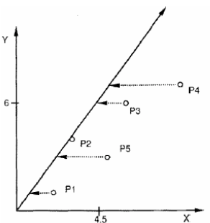
Figure 1: The Efficient Production Frontier

When there is a change on the efficient production frontier, an upward or downward shift the productivity will change. These changes in productivity can be due to improvements in technical efficiency.

For the analysis I am using the linear programming form as stated above in (B). This model is known as the CCR (Charnes, Cooper, Rhodes, 1978) input oriented model and this model will examine the DMUs on the efficient production frontier. A 100% rating means that the country (DMUs used here) is operating at maximum performance with regard to the utilization of its inputs in the production of its outputs.

The important feature of DEA is it can evaluate the relative performance (i.e. efficiency) of any number of decision making units (DMUs), which are responsible for converting inputs into outputs. This model will yield an efficiency score for each DMU within the range 0 to1.00, where 1.00 corresponds to 100% or maximum efficiency compared to all other DMUs. The inefficient units’ are compared to efficient ones and possibly improve their performance.

Data Collection:

Data used in this analysis was collected form different sources, the World Bank, the Trading Economics, the International Telecommunications Union (ITU), the United Nations data (UN data), and the Organization for Economic Co-operation and Development (OECD). The World Bank is a database for all the statistics for countries. The Trading Economics provides exact information and also historical data for many countries about economic indicators, exchange rates, commodity prices and so on. The International Telecommunications Union is a database for all researchers for complete statistical data collected over years for the telecommunication sector for all the countries. The United Nations provides data regularly about economic and social indices for a wide set of categories for all countries. The Organization for Economic Co-operation and Development is one of the world’s largest database having the data of economic and social indicators for all countries.

Input Variables | Output Variables
Population | Revenue from ICT
Investment in ICT | No. of Internet Users
 | No. of telephone lines
 | No. of mobile subscriptions

Table 2: List of Variables used in the DEA Analysis

The data required for this analysis was obtained from all the sources mentioned above and was collected for the years 2000 and 2009. The input and output variables used in the DEA Analysis of the ICT sectors for the fifteen Southern African countries are in the table 2 above. Here, I want to demonstrate the impact of ICT investments, therefore I identified the above variables. These variables are useful in determining how much more investments have to be made to the ICT infrastructure so that there is a good Revenue growth.

Discussion of Results:

The first question was, are the ICT investments resulting in revenue growth? According to the data which was collected from various sources, it was clearly seen that the countries have heavily invested in ICT and also the revenue which resulted was also high. The data were collected for the years 2000 and 2009 respectively. It was observed that the ICT investments made in the year 2009 were higher when compared to the ICT investments in the year 2000. This was due to the fact that the revenue generated in year 2000 saw a significant profit. All the fifteen countries contributed to this profit. All of the fifteen countries performed well in generating a revenue from the investments. Therefore, again in the year 2009 ICT investments saw an increase and the revenue again made a profit. This shows the potential impact of ICT investments on making profit for the countries. When large amounts of money is invested in ICT, gives ways to new markets and services and thereby creating new opportunities for people for jobs and employment which aids in economic development of the country.

The second question, are the Southern African countries technically efficient with regard to the ICT investments and utilizing ICT? The DEA analysis was performed on the data collected for the years 2000 and 2009 respectively. The relative efficiency scores were calculated for the fifteen countries. The dual linear programming formula of DEA (as stated earlier on Page 8) was used. The main reason for using the dual form was to reduce the number of constraints on the model, so that the model works easily. The countries which are considered for the study are the DMUs. The countries can be divided into best practice and worst practice countries based on their relative efficiency scores. The DMUs that make maximum use of the inputs and produce maximum output, will have an efficiency score of 1 or 100% and are efficient when compared to the countries that receive an efficiency score less than 1 are inefficient. The constraints in the DEA analysis are the factors affecting the impact of ICT investments which are Population, Investment in ICT, Revenue from ICT, Number of Internet users, Number of Telephone lines, and Number of Mobile Subscriptions. These factors give information about how the ICT investments impact on the infrastructure utilization. As the investments increases, more ICT services are created and which in turn increases the number of users of these services. Therefore, the revenue from these services should make a profit to the country. Finally, the country will be technically efficient in comparison to the rest of the fourteen countries used in the study. As and when new ICT services have to be created, then comes the question of the infrastructure that is necessary for the utilization of ICT. Therefore the ICT investments are indirectly dependent on the ICT infrastructure. When a country which is technically efficient, that particular country is making use of the ICT investments and also ICT infrastructure which is in place.

In the year 2000, seven countries were technically efficient. Botswana, Namibia, South Africa, Swaziland, Kenya, Lesotho, and Zimbabwe were the countries which gave an efficiency score of 1 when DEA analysis was performed. Tanzania was the least efficient country with a score as low as 0.23506. The table 3 below gives the detailed efficiency scores of all the fifteen countries. When the Gross Domestic Product (GDP) and Human Development Index (HDI) of all the countries were noted down. It was also observed that the countries which had the lowest figure for GDP and HDI, were the countries which had received an efficiency score less than with the DEA analysis. Therefore, the DEA analysis provides a method to determine the efficiency of the countries which is valid.

In the year 2009, eleven countries were found to be technically efficient. Therefore within a span of nine years four other countries improved their efficiency. This can be mainly due to the fact that these four countries Madagascar, Angola, Tanzania, and Malawi have made right use of the ICT investements. And therefore resulted in the increase in their respective efficiency scores. It was also observed that the countries which were efficient during the year 2000 still remained efficient in the year 2009. The table 4 below gives the detailed efficiency scores of all the fifteen countries. As seen from the table, Tanzania which was the least performer in year 2000 with a score of 0.23506 has a score of 1 in the year 2009. This is a very high increase in the efficiency score of about 0.76494. These increase in efficiency scores, shows how the ICT are contributing to the development of the countries. It can also seen from the table that Democratic Republic of Congo is the least efficient country in the year 2009 with a score of 0.48706.
 | Year 2000
Countries | Efficiency | GDP per captia ($US) | HDI
Botswana | 1 | 3204 | 0.633
Namibia | 1 | 2062 | 0.606
South Africa | 1 | 3020 | 0.597
Swaziland | 1 | 1508 | 0.498
Kenya | 1 | 406 | 0.470
Lesotho | 1 | 380 | 0.427
Zimbabwe | 1 | 535 | 0.140
Malawi | 0.864564 | 155 | 0.385
Angola | 0.585591 | 656 | 0.402
Mozambique | 0.472872 | 233 | 0.284
Uganda | 0.413843 | 256 | 0.422
Madagascar | 0.370460 | 252 | 0.435
Zambia | 0.277745 | 317 | 0.395
Democratic Republic of Congo | 0.247021 | 87 | 0.239
Tanzania | 0.235067 | 307 | 0.398

Table 3: Efficiency scores computed from DEA analysis for the year 2000

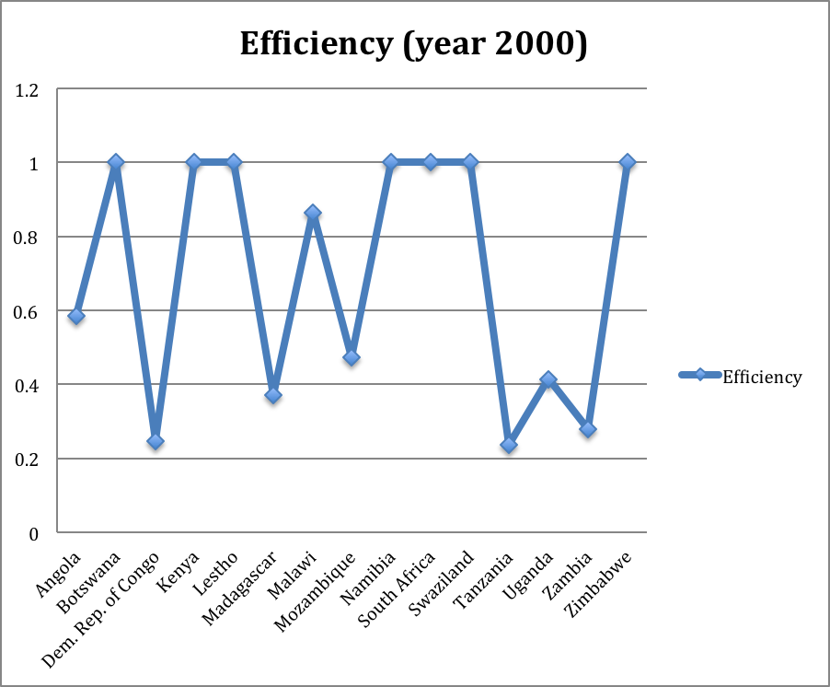
Figure 2: The relative efficiency trend of the fifteen African countries in the year 2000

 | Year 2009
Countries | Efficiency | GDP per capita ($US) | HDI
Botswana | 1 | 5790 | 0.633
Namibia | 1 | 4096 | 0.606
South Africa | 1 | 5733 | 0.597
Swaziland | 1 | 2827 | 0.498
Kenya | 1 | 775 | 0.470
Madagascar | 1 | 422 | 0.435
Lesotho | 1 | 796 | 0.427
Angola | 1 | 4069 | 0.402
Tanzania | 1 | 503 | 0.398
Malawi | 1 | 327 | 0.385
Zimbabwe | 1 | 468 | 0.140
Uganda | 0.90318 | 488 | 0.422
Zambia | 0.86497 | 1006 | 0.395
Mozambique | 0.73668 | 428 | 0.284
Democratic Republic of Congo | 0.48706 | 175 | 0.239

Table 4: Efficiency scores computed from DEA analysis for the year 2009
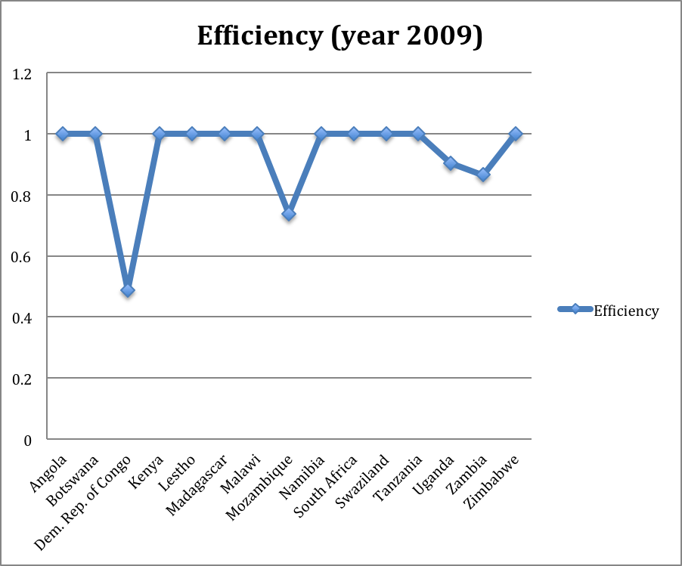
Figure 3: The relative efficiency trend of the fifteen African countries in the year 2009

Conclusion:

The DEA analysis performed on the fifteen countries in Southern Africa for the data collected for the years 2000 and 2009 gave us some intriguing empirical evidence regarding the impact of ICT investments. I have chosen DEA analysis for this study because there was not enough data available where I could perform regression analysis to determine the correct correlations between different factors. However with DEA method I was able to answer the two basic questions of this research: (1) Are the ICT investments resulting in Revenue Growth ? and (2) Are the countries technically efficient with regard to the ICT investments ? The DEA results computed for the year 2000 suggested that Botswana, Namibia, South Africa, Swaziland, Kenya, Lesotho, and Zimbabwe were the best practice countries and for the year 2009, DEA suggested that Botswana, Namibia, South Africa, Swaziland, Kenya, Madagascar, Lesotho, Angola, Tanzania, Malawi, and Zimbabwe were the best practice countries. This study was made only to see if the ICT investements were generating any revenue and also if the countries are technically efficient.

References:

Shafer, S. and Byrd, T. (2000) A Framework for Measuring the Efficiency of Organizational Investments in Information Technology Using Envelopment Analysis, Omega: the International Journal of Management Science.

Wang, C., Gopal, R. and Zionts, S, (1997) Use of Data Envelopment Analysis in Assessing Information Technology Impact on Firm Performance, Annals of Operations Research.

Chen, Y. and Zhu, J. (2004) Measuring Information Technology’s Indirect Impact on Firm Performance, Information Technology & Management.

Okello, R.M (2010). Infrastructure and Intra- African trade.

ITU: International Telecommunication Union (2007b).Telecommunication/ICT Markets and Trends in Africa Report.

UNCTAD: United Nations Conference on Trade and Development (2009). Economic Development in Africa: Strengthening Regional Economic Integration for Africa’s Development. United Nation, New York.

World Bank (2010). World Bank Indicators, World Bank. http://data.worldbank.org/data-catalog/africa-development-indicators˙

Bankole, F.O., Osei-Bryson, K.M. and Brown, I. ICT Infrastructure Utilization in Africa: Data Envelopment Analysis Based Exploration

Bollou, F. ICT Infrastructure Expansion in Sub-Saharan Africa: An Analysis of Six West African Countries From 1995 to 2002.

Cooper, W.W, Seiford, L.M, and Zhu, J. Data envelopment analysis: history models and
interpretations

Cook, W.D., Zhu, J. Data Envelopment Analysis: Modeling Operational Processes and Measuring Productivity. 2008.

Cooper,W.W., Seiford, L.M., Tone, K. Introduction to Data Envelopment Analysis and its Uses. Springer 2006.

Shenyun Jun and Choon-Kyeong Kim. Strategy Comparison with Optimization

Mungamuru, N., Kaliyaperumal, K., Appalabatla, S. and Patharaj, J. The Role of ICT in the Economic Development of North East Africa: Eritrea, Journal of Emerging Trends in Computing and Information Sciences

Kelles-Viitanen, A. The Role of ICT in Governing Rural Development

Williams, Mark D.J.; Mayer, Rebecca; Minges, Michael . Africa’s ICT Infrastructure, World Bank

Langmia, K. The role of ICT in the economic development of Africa: The case of South Africa, International Journal of Education and Development using Information and Communication Technology

Fourie, Louis; Edited by McNamara, Kerry. Enhancing the Livelihoods of the Rural Poor Through ICT: A Knowledge Map, South Africa Country Map June 2008

Prof. Samuel Wangwe. A Review of Methodology for Assessing ICT Impact on Development and Economic Transformation

Good Practice Paper on ICTs for Economic Growth and Poverty Reduction – © OECD 2005, prepared by Mr. Simon Batchelor and Mr. Nigel Scott, Gamos Ltd, with inputs from Mr. David Woolnough.

Bollou, Felix; Ngwenyama, Ojelanki; Morawczynski, Olga, The Impact of Investments in ICT, Health and Education on Development: A DEA Analysis of Five African Countries from 1993-1999

http://www.tradingeconomics.com/angola/indicators

http://databank.worldbank.org/ddp/home.do

http://stats.oecd.org/

http://hdr.undp.org/en/statistics/

Appendix A

Data used for Input Variables :
 | Year 2000
Countries | Population (in millions) | Investment (in US$ millions)
Angola | 13926373 | 6800000
Botswana | 1757925 | 17000000
Democratic Republic of Congo | 49626200 | 41200000
Kenya | 31253701 | 130000000
Lesotho | 1963878 | 2800000
Madagascar | 15364272 | 899651014
Malawi | 11228756 | 4700000
Mozambique | 18200656 | 9690520
Namibia | 1895839 | 8750000
South Africa | 44000000 | 1840000000
Swaziland | 1010786.549 | 5400000
Tanzania | 34038161 | 33300000
Uganda | 24213120 | 57100000
Zambia | 10201562 | 27000000
Zimbabwe | 12509477 | 8000000

 | Year 2009
Countries | Population (in millions) | Investment (in US$ millions)
Angola | 18555115 | 51847423
Botswana | 1981576 | 483374848
Democratic Republic of Congo | 64204304 | 474331488
Kenya | 39462188 | 744719936
Lesotho | 2149201 | 1963976
Madagascar | 20124150 | 63815612
Malawi | 14442290 | 185845723
Mozambique | 22858607 | 138049872
Namibia | 2242078 | 2032782
South Africa | 49320150 | 11177345012
Swaziland | 1043509 | 28325868
Tanzania | 43524738 | 688255962
Uganda | 32367909 | 379570176
Zambia | 12723746 | 123508436
Zimbabwe | 12473992 | 113529382
Data used for Output Variables :

 | Year 2000
Countries | Revenue (in US$ millions) | Internet Users | Telephone lines | Mobile cellular subscriptions
Angola | 412501120 | 14629.03685 | 64900 | 25806
Botswana | 945000000 | 51026.70221 | 135900 | 222190
Democratic Republic of Congo | 7128600320 | 2928.994739 | 9810 | 15000
Kenya | 23352999936 | 99405.43189 | 291706 | 127404
Lesotho | 80000000 | 4159.612819 | 22200 | 21600
Madagascar | 5396514656 | 30174.61452 | 54995 | 63094
Malawi | 1806800000 | 14235.92294 | 46444 | 49000
Mozambique | 1690812023 | 19946.55939 | 85714 | 51065
Namibia | 843587008 | 31181.61379 | 110176 | 82000
South Africa | 47401000960 | 2394035.661 | 4961743 | 8339000
Swaziland | 263772000 | 9853.124508 | 31858 | 33000
Tanzania | 139021939.1 | 39890.83221 | 173591 | 110518
Uganda | 6357482124 | 39640.28255 | 61678 | 126913
Zambia | 199889212.8 | 19492.29207 | 83326 | 98853
Zimbabwe | 7186999808 | 50217.23576 | 249400 | 266441

 | Year 2009
Countries | Revenue (in US$ millions) | Internet Users | Telephone lines | Mobile cellular subscriptions
Angola | 40847404 | 608607.772 | 303179 | 8109421
Botswana | 395488512 | 121866.924 | 137422 | 1874101
Democratic Republic of Congo | 737300416 | 359544.1024 | 42320 | 9458557
Kenya | 1917672576 | 3962003.675 | 664099 | 19364559
Lesotho | 1463769 | 79857.332 | 40000 | 661000
Madagascar | 346461248 | 328023.645 | 186150 | 6283799
Malawi | 1458832600 | 154532.503 | 111333 | 2374051
Mozambique | 467334624 | 612610.6676 | 82447 | 5970781
Namibia | 1632769 | 131666.0096 | 142100 | 1217000
South Africa | 19161004032 | 4975150.3 | 4319800 | 46436000
Swaziland | 126376952 | 88794.22 | 44000 | 656000
Tanzania | 768280960 | 4352473.8 | 172922 | 17469486
Uganda | 668280960 | 3165581.5 | 233533 | 9383734
Zambia | 273508000 | 802868.3726 | 90341 | 4406682
Zimbabwe | 223508345 | 1417045.491 | 385116 | 2991000

